|  |  |  |  |  |  |  |  |  |  |  |  |  |  |  |
| --- | --- | --- | --- | --- | --- | --- | --- | --- | --- | --- | --- | --- | --- | --- |
| |  |  | | --- | --- | | Team name | 6droids | | 14208971 | Tharkana D Kodagoda | | 14208893 | Sahitha Nelanga H De Silva | | 14208910 | H W Srimal Priyanga Fonseka | | 14209059 | Dilina Namal Weerasinghe | | 14209074 | P W Poorni Yasodara | | 14209759 | Kavindu Yudeesha Lakshan Narathota | |

|  |
| --- |
| Assignment – Object Oriented Design (COMP3004L) |
| Final Project Report |



Contents

1. Domain Analysis 0

2. Structural Diagrams 0

2.1. Class diagram 0

2.2. Object diagram 0

2.3. Component diagram 0

2.4. Deployment diagram 0

3. Behavioral Diagrams 0

3.1. Use case diagram 0

3.2. Sequence diagram 0

3.3. Activity diagram 0

1. Domain Analysis

|  |
| --- |
| Client(Player) |
| playerID:Integer |

|  |
| --- |
| Game Rummy |
| RummyGame |
| Draw |
| Discard |
| Card |
| Deal |

|  |
| --- |
| Game Switch |
| SwitchGame |
| Draw |
| Discard |
| Card |
| Deal |

1. Structural Diagrams
   1. Class diagram



Figure 1 - Class Diagram

* 1. Object diagram



Figure 2 - Object Diagram (Switch)



Figure 3 - Object Diagram (Rummy)

* 1. Component diagram



* 1. Deployment diagram



1. Behavioral Diagrams
   1. Use case diagram



Figure 4 – Use case Diagram

* 1. Sequence diagram

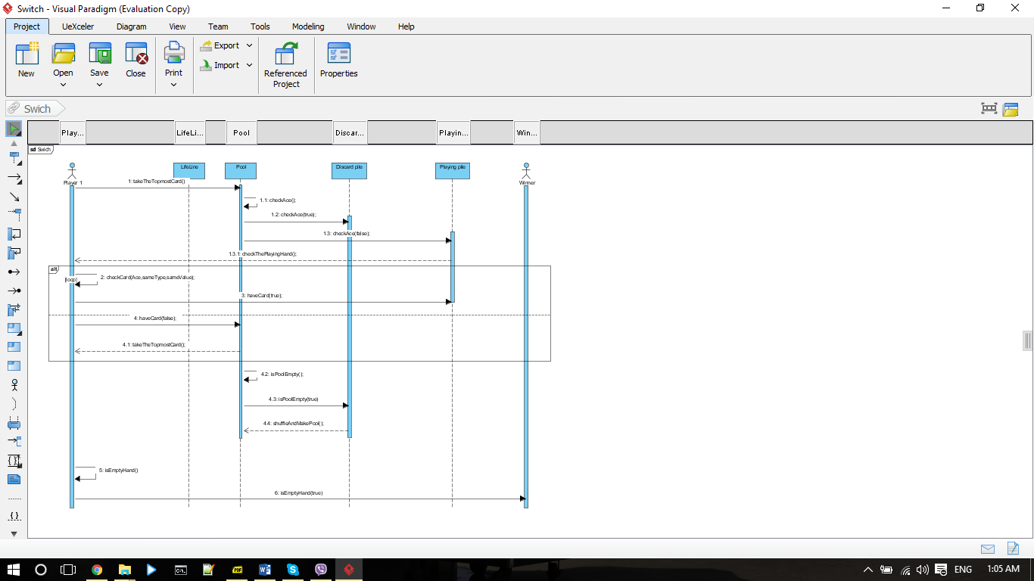

Figure 5 - Sequence Diagram (Switch)

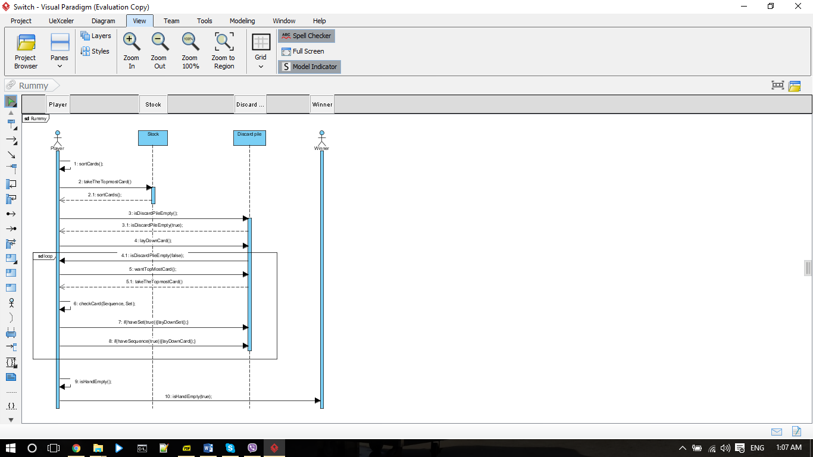

Figure 6 - Sequence Diagram (Rummy)

* 1. Activity diagram